FINAL EXAMINATION
Course Title: Art Appreciation
PART I – Multiple Choice (Situational Type) [2 pts each]
Choose the best answer that applies to the situation described. Shade the correct letter on your answer sheet.
- Ana watched a performance where the poet emotionally recited verses about mental health and social justice. What art form is being showcased?
a. Visual Art
b. Sculpture
c. Spoken Word Poetry
d. Painting
- A group of young people creates murals in the community that depict local folklore. This act reflects which function of art?
a. Political
b. Personal
c. Social
d. Physical
- Mark insists that art should always be beautiful and pleasing to the eye. This belief reflects which assumption about art?
a. Art must imitate nature.
b. Art is for everyone.
c. Art is always expressive.
d. Art must have aesthetic value.
- During a poetry slam, one performer narrates the struggles of growing up in poverty. This reflects art's function as:
a. Utilitarian
b. Political
c. Historical
d. Decorative
- When visiting a museum, Claire observed a series of sculptures representing human figures from different time periods. What is being showcased?
a. Art as propaganda
b. Art as self-expression
c. Art through historical evolution
d. Art as entertainment
- A teacher uses artworks from different historical periods to explain how societies change over time. What aspect of art is this?
a. Art as therapy
b. Evolution of art
c. Commercial art
d. Performance art
- In a spoken word piece, the poet blends rhythm, facial expressions, and movement. What kind of art elements are being utilized?
a. Abstract and Surrealist
b. Literary and Performing Arts
c. Digital and Applied Arts
d. Sculptural and Musical Arts
- Jose wants to communicate his personal trauma through painting. What function of art does this reflect?
a. Physical
b. Social
c. Emotional expression
d. Political
- A student critiques an artwork based on its historical significance and influence. What kind of art appreciation is applied?
a. Technical
b. Contextual
c. Aesthetic
d. Emotional

- During a festival, a spoken word artist recites poetry promoting women's rights. What role does the artist play in society?
a. Entertainer
b. Historian
c. Advocate
d. Craftsman
- A community center uses art therapy sessions for children affected by trauma. This illustrates which function of art?
a. Recreational
b. Educational
c. Psychological
d. Decorative
- Mural paintings showing national heroes in schools demonstrate:
a. Personal function of art
b. Cultural preservation through art
c. Abstract representation of history
d. Modern artistic expression
- Spoken word poetry differs from traditional poetry mainly because it:
a. Uses rhyme schemes
b. Is read silently
c. Is written for performance
d. Avoids emotional themes
- Art movements from Classical to Contemporary demonstrate:
a. Assumption that art is timeless
b. Evolution of art through history
c. Art’s religious purpose
d. Subjective appreciation
- After analyzing an abstract painting, Liza says, "I don’t understand this; it doesn't look real." Her statement reveals which assumption?
a. Art must reflect beauty
b. Art must imitate life
c. Art is about shock value
d. Art is only for experts
- A poet uses spoken word to express pain from discrimination. This art primarily serves:
a. A decorative function
b. An expressive and political function
c. A ritualistic function
d. A narrative function
- Which of the following is the best evidence that art evolves?
a. Artworks are hung in museums
b. Styles and materials used change over time
c. Artists now earn more
d. Poetry is taught in schools
- A spoken word poet uses modern slang and current social issues in her poem. This shows:
a. Traditionalism
b. Conservatism
c. Relevance and adaptation
d. Rejection of art
- During the Renaissance, art focused on religious themes, while modern art explores identity and politics. This shift proves:
a. All art is the same
b. Art's function does not change
c. Art evolves alongside society
d. Old art is better
- A person claims, "Only the educated can appreciate true art." What assumption is reflected here?
a. Art is for the elite
b. Art is democratic
c. Art is for self-expression
d. Art is functional
- A spoken word artist uses her platform to denounce gender inequality. Her poetry is an example of:
a. Fantasy art
b. Satirical art
c. Empowerment through art
d. Religious narrative
- Art in ancient times served as a tool to document events. Today, it is also used for activism. This shows:
a. Consistency in art’s form
b. Fixed purpose of art
c. Evolution of art’s functions
d. Art losing its value
- You are asked to describe a painting based on your feelings. What kind of appreciation is applied?
a. Technical
b. Contextual
c. Emotional
d. Intellectual
- The belief that art is only for galleries and exhibitions reflects what type of assumption?
a. Art must be expensive
b. Art is exclusive
c. Art is universal
d. Art is subjective
- Spoken word poetry emphasizes delivery. What is MOST crucial for this type of performance?
a. Grammar
b. Voice and expression
c. Costume and design
d. Rhyming
- Art in the digital age includes memes, GIFs, and TikTok videos. This represents:
a. Decline in traditional art
b. Loss of artistic value
c. Evolution and accessibility of art
d. Art becoming irrelevant
- A teenager uses visual journaling to manage anxiety. What function of art is evident?
a. Psychological and therapeutic
b. Political and revolutionary
c. Decorative and commercial
d. Historical and archival
- Which of the following shows art's evolution from oral tradition to modern platforms?
a. Cave painting
b. Spoken word on YouTube
c. Stone sculpture
d. Ancient scripts
- A group of artists stages a play to promote environmental awareness. What role of art is shown?
a. Entertainment only
b. Political and social awareness
c. Therapy
d. Craftsmanship
- A viewer says, “Art must serve a purpose.” This statement best reflects what view of art?
a. Art for art’s sake
b. Art as function
c. Art as mystery
d. Art as fantasy

PART II. DEFINE THE FOLLOWING TERM (10 POINTS)
Direction: In your own words, explain the following in one (2) sentences based from the example painting.

- Art is Universal _________________________________
- Art is not Nature ________________________________
- Art is involves experience __________________________

PART III – Painting Analysis (20 pts)
Instruction: Observe the painting below. Analyze it using the guide questions provided. Write your essay in a well-structured paragraph form.

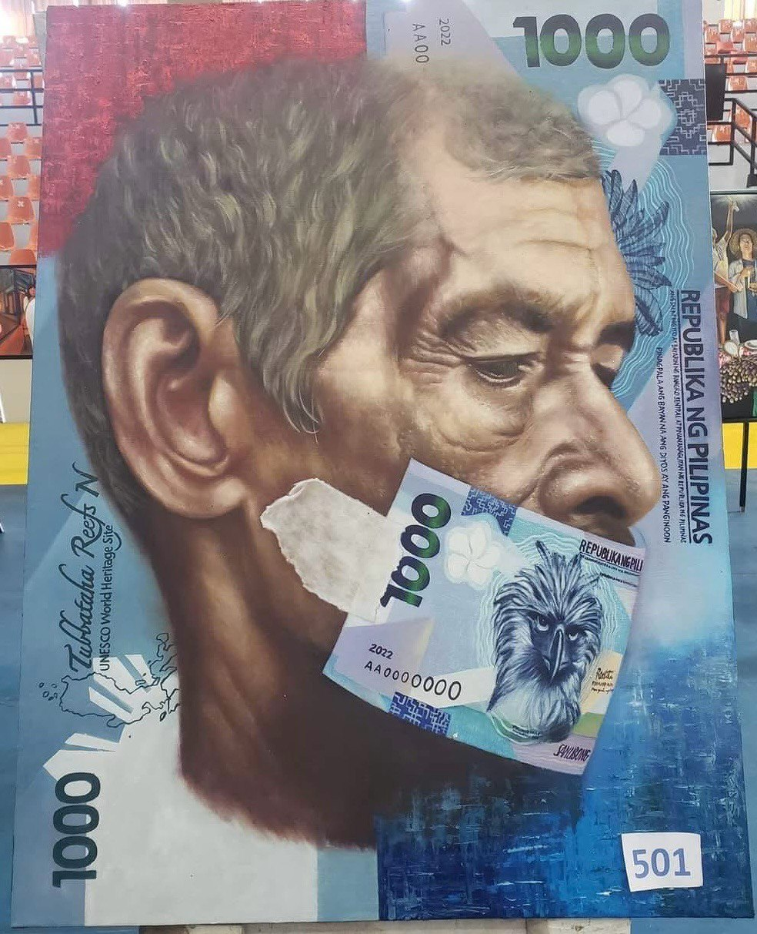

Guide Questions:
- What is the painting about? What’s your interpretation?
- What emotions does it evoke in you as a viewer?
- How does it reflect the time and culture it was made in?

